User Guide: Management Dashboard

# Overview

The Management Dashboard provides a centralized interface to explore and analyze team contributions by vendor, division, contractor, and work product. It enables leadership to gain insights into effort allocation, identify trends, and explore areas requiring further attention.

# 1. Management Dashboard Interface

Upon selecting "Management Dashboard" from the sidebar, you'll access an interactive interface including filters, data tables, and visualization tools. The layout consists of a filter panel (left), data display (center), and a treemap visualization (bottom).

*Figure 1: Full Management Dashboard view*

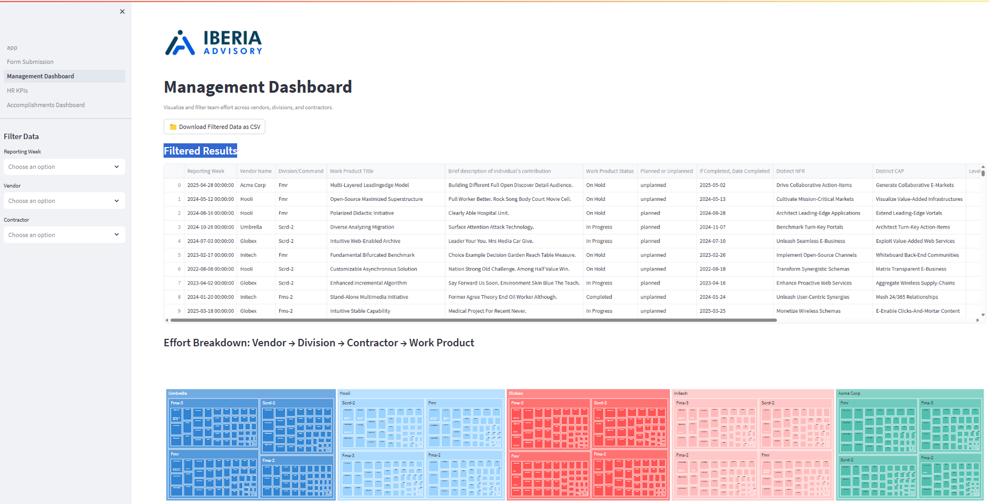

# 2. Filtering the Data

Use the left-hand filters to narrow the data shown. You can filter by:  
- Reporting Week  
- Vendor  
- Contractor  
  
Select any combination of filters to tailor the results.

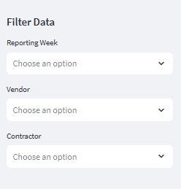

*Figure 2: Data filter controls*

# 3. Viewing Filtered Results

Once filters are applied, the main table updates to show matching weekly report records. Columns include reporting week, vendor, work product, status, contribution, and effort percentage. You can scroll horizontally and vertically to see full details.

# 4. Visualizing Effort Distribution

At the bottom, a dynamic treemap summarizes effort breakdown from Vendor → Division → Contractor → Work Product. This visualization provides a high-level view of team workload allocation across stakeholders.

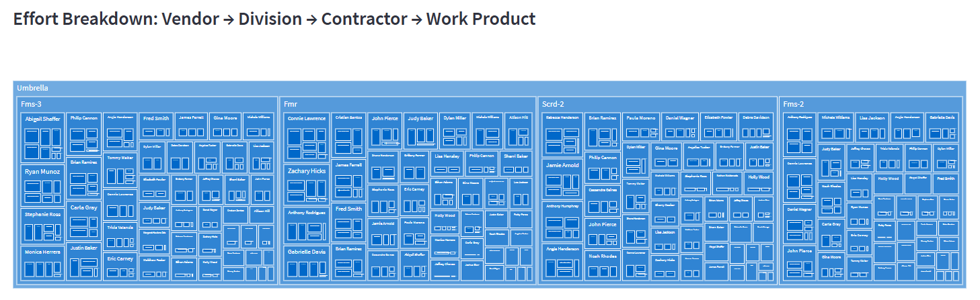

*Figure 3: Effort Breakdown Treemap*